Name of the Student | D.N Shirshika
Reg. No | 192425396
GitHub Link | https://github.com/shirshika572/Mla0403.git

SIMATS ENGINEERING

CO4 - ASSESSMENT TOOL 2

Mock Interview

COURSE NAME: Deep Learning COURSE CODE: MLA0403
SLOT: A

COURSE OUTCOME COVERED

CO 5: Autoencoders, Undercomplete Autoencoder, Regularized Autoencoder, Sparse Autoencoder, Denoising Autoencoder, Stochastic Encoders and Decoders, Contractive Autoencoder, Deep Belief Networks (DBN), Boltzmann Machines (BM), Deep Boltzmann Machines (DBM), Generative Adversarial Networks (GANs), Generator, Discriminator, GAN Applications.

Course Outcome Weightage: 35% Duration: 90 minutes
Assessment Tool Weightage: 20% Mark: 25

Code of Conduct:
I D.N Shirshika (192425396) (Name / Reg No) certify that this submission is my original work and that I have adhered to the guidelines specified for this assessment.
I understand that any violation of academic integrity rules will result in disciplinary action.

Signature of the student: Name of the student: D.N Shirshika

Criteria | Subject Knowledge and Conceptual Understanding (3) | Technical Accuracy and Application of Concepts  (2.5) | Problem-Solving and Analytical Thinking (2) | Communication Skills and Clarity of Explanation (1.5) | Confidence, Presentation and Professional Behaviour (1) | Total (10)
Weightage | 30 % | 25% | 20% | 15 % | 10 % | 100%
Q1
Q2
Q3
Q4
Q5
Q6
Q7
Q8
Q9
Q10
Q11
Q12
Q13
Q14
Q15
Q16
Q17
Q18
Q19
Q20
Q21
Q22
Q23
Q24
Q25

Total

Signature of the Faculty: Total Marks:
QUESTIONS: 25 Total Marks:25

1.What is an Autoencoder in Deep Learning?
An Autoencoder is a neural network that learns a compact representation of input data and reconstructs the original data.
2.What is the main purpose of an Autoencoder?
Its main purpose is to learn useful features. It is used for dimensionality reduction, denoising, anomaly detection, and feature extraction..
3.What are the major components of an Autoencoder?
- Encoder
- Bottleneck/Latent representation
- Decoder
4.What is the role of the Encoder in an Autoencoder?
The Encoder converts the input data into a smaller and meaningful latent representation
5.What is the role of the Decoder in an Autoencoder?
The Decoder takes the latent representation and attempts to reconstruct the original input.
6.What is meant by the Bottleneck layer in an Autoencoder?
The Bottleneck layer is the smallest or compressed representation of the input. It forces the network to retain the most important features.

7.What is meant by Reconstruction in an Autoencoder?
Reconstruction is the process of producing an output that is as close as possible to the original input.
8.How does an Autoencoder learn to reconstruct its input?
The Autoencoder compares the original input with its reconstructed output using a loss function.
9.What is the difference between an Autoencoder and a traditional Neural Network?
reconstruct its input and learn representations.
10.What type of loss function is commonly used to train an Autoencoder?
- Mean Squared Error (MSE) – for continuous data.
- Binary Cross-Entropy – commonly used for normalized/binary-type outputs.
11.Explain the basic architecture of an Autoencoder with a suitable example.
Encoder → Bottleneck → Decoder
12.Why is the dimensionality of the bottleneck layer usually smaller than the input layer?
It forces the network to learn only the most important features instead of simply copying the input.
13.What happens if the bottleneck layer has too many neurons?
The network may simply copy the input, reducing the effectiveness of feature learning and dimensionality reduction.
14.What happens if the bottleneck layer has very few neurons?
The model may lose important information, resulting in high reconstruction error and poor representation quality.
15.What is a Denoising Autoencoder?
A Denoising Autoencoder (DAE) is an Autoencoder trained to reconstruct the original clean input from a deliberately corrupted or noisy input.
16.How can an Autoencoder be used for image denoising?
A noisy image is given to the encoder. The Autoencoder learns a latent representation and the decoder reconstructs a cleaner version.
Noisy Image → Encoder → Latent Features → Decoder → Clean Image
17.How can Autoencoders be used for dimensionality reduction?
Compression
18.How can an Autoencoder be used for anomaly detection?
The model learns normal data. Normal data produces low reconstruction error, while abnormal data usually produces high reconstruction error.
19.What is the difference between a Denoising Autoencoder and a basic Autoencoder?
A basic Autoencoder reconstructs the input, while a Denoising Autoencoder reconstructs clean data from noisy input.
20.Give some real-world applications of Autoencoders.
Autoencoders are used for:
- Image denoising
- Data compression
- Anomaly detection
- Feature extraction
- Fraud detection
- Medical image analysis
21.What is a Deep Generative Model?
It is a model that learns patterns from existing data and generates new similar data.
22.What is the difference between a generative model and a discriminative model?
- Generative model: Creates new data.
- Discriminative model: Classifies or predicts data.
23.What is a Variational Autoencoder (VAE)?
A VAE is an Autoencoder that learns a probability-based latent representation and can generate new data.
24.What is the difference between a traditional Autoencoder and a Variational Autoencoder (VAE)?
- Autoencoder: Learns a fixed/compact representation.
- VAE: Learns a probability distribution and can generate new samples.

25.What are Generative Adversarial Networks (GANs), and what are the roles of the Generator and Discriminator?
A GAN consists of two networks:
- Generator: Creates fake data.
- Discriminator: Determines whether data is real or fake.
The Generator tries to fool the Discriminator, while the Discriminator tries to identify the fake data.

PHOTO:

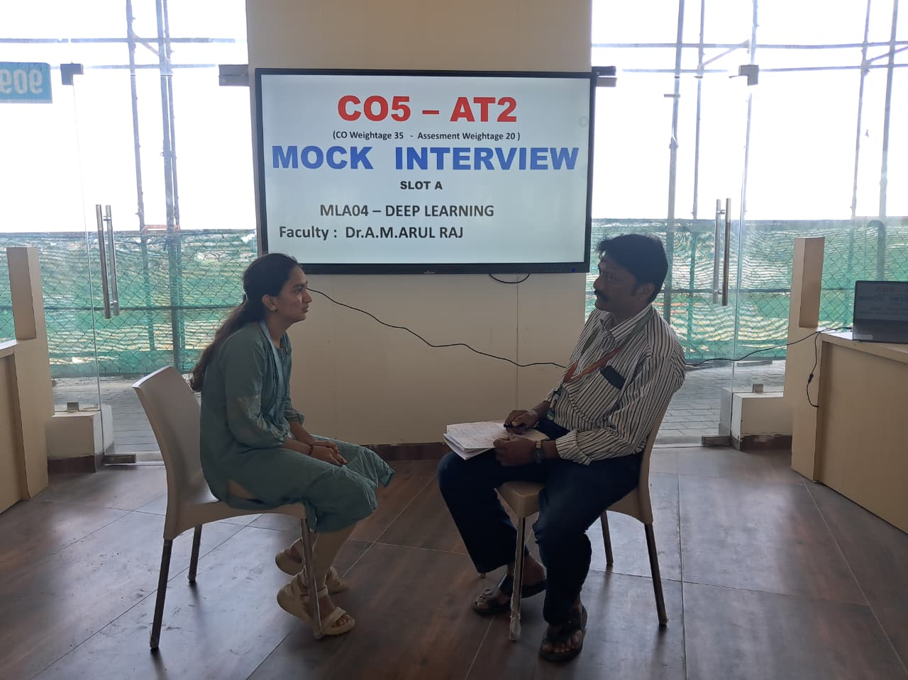

RUBRICS FOR CALCULATION:
Criteria | Weightage | Level 4 – Exemplary | Level 3 – Proficient | Level 2 – Developing | Level 1 – Beginning
Subject Knowledge and Conceptual Understanding | 30% | Comprehensive understanding of real-world problem and constraints | Good understanding with minor gaps in requirements | Basic understanding; some requirements unclear | Poor understanding; misinterprets problem context
Technical Accuracy and Application of Concepts | 25% | Applies advanced and relevant concepts effectively to solve the problem | Applies appropriate concepts with minor errors | Limited application of concepts | Incorrect or no application of concepts
Problem-Solving and Analytical Thinking | 20% | Innovative, practical, and feasible solution aligned with industry standards | Logical and feasible solution with minor gaps | Basic solution with limited feasibility | Unclear or impractical solution
Communication Skills and Clarity of Explanation | 15% | Effective use of modern tools, technologies, and real data | Appropriate use of tools with correct implementation | Limited or inconsistent use of tools | Minimal or incorrect use of tools
Confidence, Presentation and Professional Behaviour | 10% | Thorough analysis with validated results and performance evaluation | Good analysis with reasonable validation | Basic analysis with limited validation | Poor or no analysis

